Adults are responsible for Hazards. Risks help your child develop.

Hazard: A danger in the environment that could seriously injure or endanger a child and is beyond the child’s capacity to recognize. It is the adult’s responsibility to identify and address hazards

Risk: The challenges and uncertainties within the environment that a child can recognize and learn to manage by choosing to encounter them while determining their own limits.
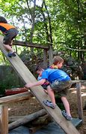
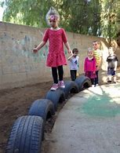
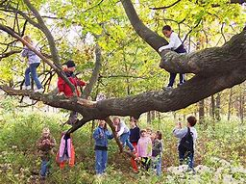
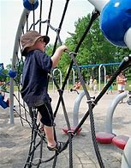
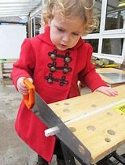

Eliminating risks leads to a child’s inability to assess danger.

